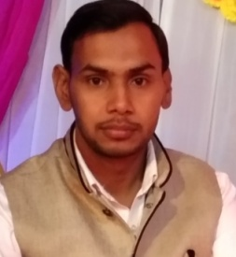

**RAHUL KUMAR**

**Work Experience**

* **FRONT END DEVELOPER Nov 2021- Feb 2023**

**AK Technology** Sector 63 Noida Uttar Pradesh

.

SKILLS



[Rahulkumarverma1122@gmail.com](mailto:Rahulkumarverma1122@gmail.com)

**Intermediate 2010-2012**

SKA Janta Inter College jahangirabad B.S.R (up)

Commerce

.

**High School 2008-2010**

SKA Janta Inter College Jahangirabad B.S.R (up)

Science



Village: Jairampur kudena

City : Bulandshahr

State : Uttar Pradesh

Pin : 203394

Html, CSS, Javascripts, Bootstraps5, Photoshop etc.

Adobe after effect, Flash, premier etc.

Basic Knowlwdge of React js

MS Office

Playing Cricket

Listning Music

Reading Newspaper

Secure a responsible career opportunity to fully utilize my knowledge and skill, while making a significant contribution to the success of the organization.

LANGUAGES

ENGLISH

HINDI



+918941873323

**EDUCATION**

**Master of Computer Application** **2018-2021**

AKTU University Lucknow

Branch: Information Technology

**Bachelor of Computer Application** **2012-2015**

CSS University Meerut

Branch: Information Technology

HOBBIES

CONTACT